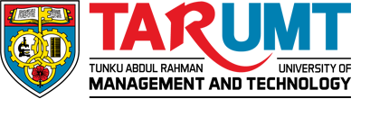

**FACULTY OF COMPUTING AND INFORMATION TECHNOLOGY**

**BMIS2003 Blockchain Application Development**

**Assignment**

**Academic Session: 202405**

**Programme: RSD3**

**Tutorial Group: Group 5**

**Team Members:**

| **No** | **Student Name & Photo** | **Student ID** | **Signature** |
| --- | --- | --- | --- |
| **1** | **Chiew Chin Chong** | **2309303** | **Chiew** |
| **2** | **Loh Jian Wei** | **2309343** | **Loh** |
| **3** | **Ong Yee Yung** | **2309357** | **OYY** |
| **4** | **Lim Weng Ni** | **2309341** | ***lim*** |
| **5** | **Tan Chee Fung** | **2309363** | **tan** |

**Coursework Declaration**

Academic Session : 202405

Course Code & Title : BMIS2003 Blockchain Application Development

**Declaration**

I/We confirm that I/we have read and shall comply with all the terms and conditions of TAR UMT’s plagiarism policy.

I/We declare that this assignment is free from all forms of plagiarism and for all intents and purposes is my/our own properly derived work.

| No | Name | ID | Signature |
| --- | --- | --- | --- |
| 1 | Chiew Chin Chong | 2309303 | Chiew |
| 2 | Loh Jian Wei | 2309343 | Loh |
| 3 | Ong Yee Yung | 2309357 | OYY |
| 4 | Lim Weng Ni | 2309341 | ***lim*** |
| 5 | Tan Chee Fung | 2309363 | tan |

Date : 22/9/2024

### Introduction

The blockchain durian tracking system is an innovative solution designed to enhance the transparency, traceability, and integrity of the durian supply chain. Nowadays, the authenticity and quality of durians have become key issues in the global market, which demands high-grade products. Blockchain technology provides an immutable, transparent record of the durian's journey from the retailer to the consumer, ensuring the fruit's quality and authenticity at every step.

Next, blockchain is a decentralized distributed ledger technology whose main core is to provide an environment to ensure that durian can be securely and verifiably tracked at every stage of the supply chain. Information about origin, harvest date, quality inspection and shipping details are recorded in an immutable ledger, so it remains accurate and tamper-proof. Decentralization enhances the system resistance against attack by others or system failures. Since data is stored in a distributed network node, it is immune to the data such as the durian origin and quality state modified by others or data loss compared to a transitional system.

Finally, the blockchain durian tracking system improves supply chain efficiency and addresses issues related to fraud, counterfeit goods, and food safety. The system provides a reliable and transparent way to trace the origin of durian; thereby providing consumer confidence, supporting regulatory compliance, and promoting responsible and more sustainable supply chains. This helps in maintaining high quality and standard durian fruit and also ensure consumer trust and satisfaction.

### Business Rules

**Retailer**

Add harvest information:The retailer can input the harvest information such as durian quality , condition, type, location into the blockchain.

Verify authenticity:Verify the authenticity of the durians by accessing the blockchain records.

Modify the timelock: The retailer can modify the timeLock for the harvest information before the ripenDate, and the customers can't buy the durian before the timeLock starts.

View the durian record: The retailer can view the record for the harvest information based on the durian id.

**Consumer**

Purchase durian:The consumer can login to the blockchain system to purchase the durian.

Verify authenticity:Verify the authenticity of the durians by accessing the blockchain records.

**Description**

**Durian Tracking System**

1. Unique Identifier: Each durian must be assigned a unique identifier (ID) upon entry into the system to ensure traceability.
2. Data Integrity: All data entries related to the durian's journey (from farm to market) must be immutable once recorded on the blockchain. This ensures that information cannot be altered without trace.
3. Transparency and Reporting: The system should provide transparent access to the tracking history of each durian for consumers and regulatory bodies. Reporting features should be available for audits and inspections.
4. Payment: All the payments must be handled through smart contracts, all the payments should be made using Ethereum.

### Contract Diagram

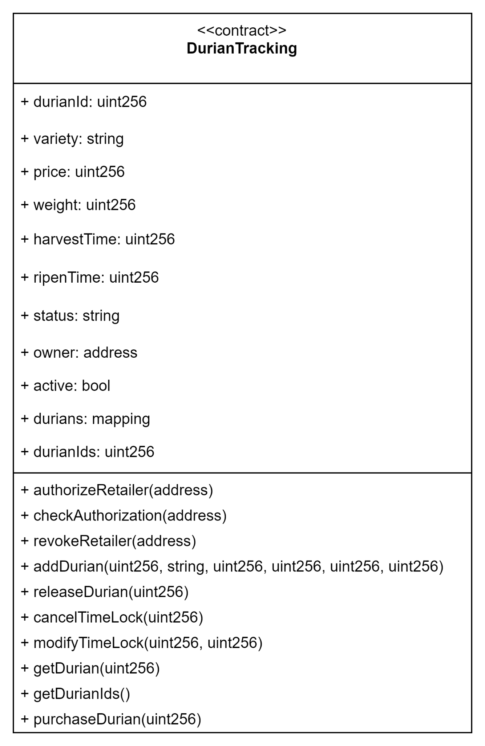

### Activity Diagram

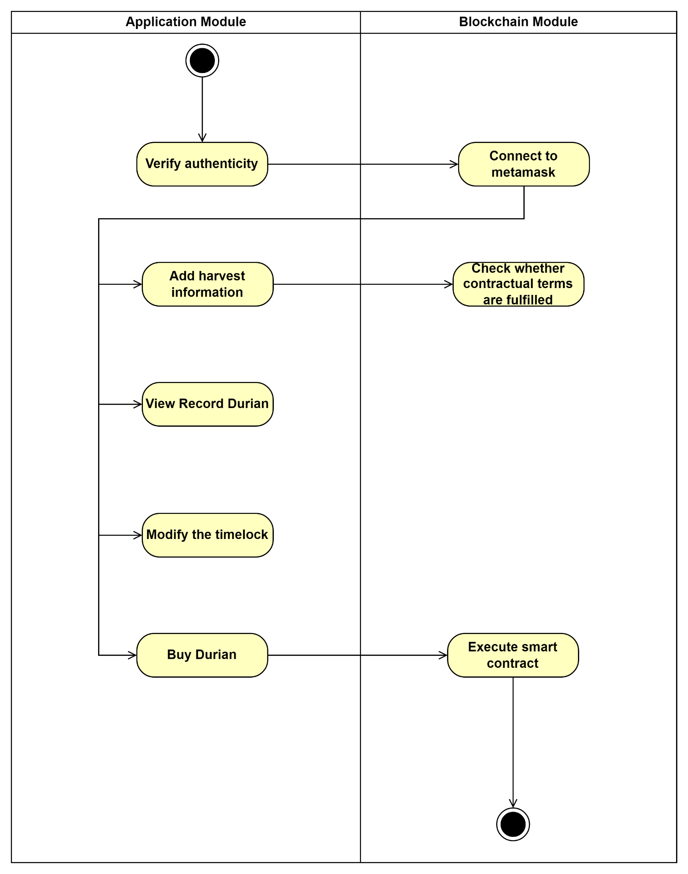

### Use Case Diagram

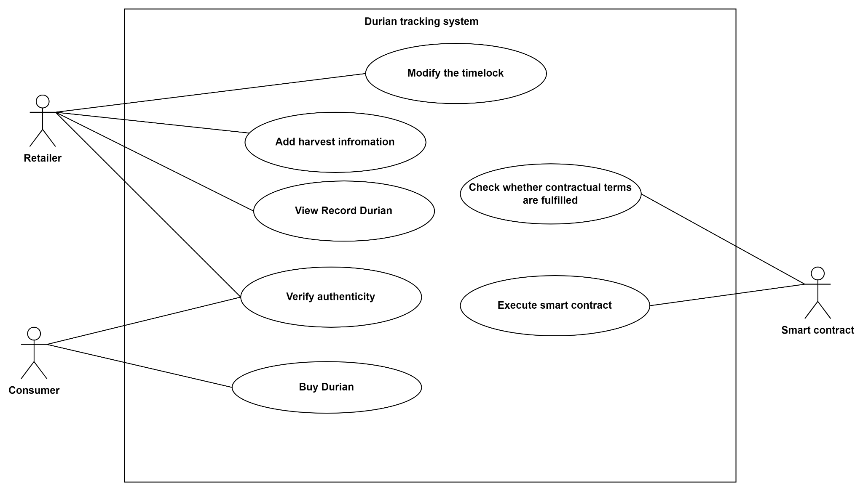

### System Architecture/Design Structure

